Wireframe – Game Website

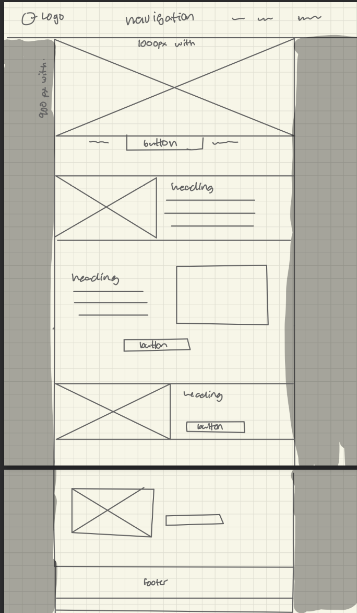this is a template the Game website and will be used for all the pages.